A MINI PROJECT REPORT ON-
FINDING THE NOTES PRESENT IN GUITAR CHORD WITH THE HELP OF FAST FOURIER TRANSFORM

Submitted to

Mr. Amit Rege

Submitted by

Prakhar Paliwal (EN17EL301101)

Rajat Patidar (EN17EL301109)
Rishabh Jain (EN17EL301115)

in partial fulfilment of Mini Project

IN

DIGITAL SIGNAL PROCESSING

At


MEDICAPS UNIVERSITY, INDORE

Jan-May, 2019

Contents

- Introduction

- Relevant Theory

- Objective

- Methodology

- Program code

- Result

- Conclusion
- Bibliography

INTRODUCTION
In music, a note is the pitch and duration of a sound, and also its representation in musical notation (♪, ♩). A note can also represent a pitch class. Notes are the building blocks of much written music
A chord, in music, is any harmonic set of pitches consisting of multiple notes that are heard as if they were sounding simultaneously. A musical note refers to the pitch class set of C,C#,D,D#,E,F,F#,G,G#,A,A#,B and the intervals between the notes are known as half-note interval or semitone interval. Thus chords can be seen as musical features and they are the principal harmonic content that describes a musical piece.
A chord has a basic construction known as a triad so called because they consist of three distinct notes that includes notes identified as a fundamental (the root note), and intervals of a third and a fifth above the root note. Chords with more than three notes include added tone chords, extended chords and tone clusters. The root can be any note chosen from the pitch class set, and it is used as a first note to construct the chord and it also gives name to the chord.
The Fourier transform (FT) decomposes a function of time (a signal) into its constituent frequencies. This is similar to the way a musical chord can be expressed in terms of the volumes and frequencies of its constituent notes. The term Fourier transform refers to both the frequency domain representation and the mathematical operation that associates the frequency domain representation to a function of time.
The Fourier transform of a function of time is itself a complex-valued function of frequency, whose magnitude component represents the amount of that frequency present in the original function, and whose complex argument is the phase offset of the basic sinusoid in that frequency. The Fourier transform is not limited to functions of time, but the domain of the original function is commonly referred to as the time domain. There is also an inverse Fourier transform that mathematically synthesizes the original function (of time) from its frequency domain representation.
MATLAB (matrix laboratory) is a multi-paradigm numerical computing environment and proprietary programming language developed by MathWorks. MATLAB allows matrix manipulations, plotting of functions and data, implementation of algorithms, creation of user interfaces, and interfacing with programs written in other languages, including C, C++, C#, Java, Fortran and Python.
A fast Fourier transform (FFT) is an algorithm that computes the discrete Fourier transform (DFT) of a sequence, or its inverse (IDFT). Fourier analysis converts a signal from its original domain (often time or space) to a representation in the frequency domain and vice versa. The DFT is obtained by decomposing a sequence of values into components of different frequencies. This operation is useful in many fields, but computing it directly from the definition is often too slow to be practical. An FFT rapidly computes such transformations by factorizing the DFT matrix into a product of sparse (mostly zero) factors.

RELEVANT THEORY
Fourier Transform-
The Fourier Transform is a tool that breaks a waveform (a function or signal) into an alternate representation, characterized by sine and cosines. The Fourier Transform shows that any waveform can be re-written as the sum of sinusoidal functions. Virtually everything in the world can be described via a waveform - a function of time, space or some other variable. For instance, sound waves, electromagnetic fields, etc. The Fourier Transform gives us a unique and powerful way of viewing these waveforms. The Fourier transform is important in mathematics, engineering, and the physical sciences
The Fourier transform is a reversible, linear transform with many important properties. For any function f(x) (which in astronomy is usually real-valued, but f(x) may be complex), the Fourier transform can be denoted F(s), where the product of x and s is dimensionless. Often x is a measure of time t (i.e., the time-domain signal) and so s corresponds to inverse time, or frequency (i.e., the frequency-domain signal).
The Fourier transform is defined by
$$F\left(s\right)=\int_{-∞}^{∞}{f\left(x\right)e^{-2πisx}}dx$$
which is usually known as the forward transform.
$$f\left(x\right)=\int_{-∞}^{∞}{F\left(s\right)e^{2πisx}}ds$$
which is the inverse transform.
In both cases, i=$\sqrt{-1}$.

The Discrete Fourier Transform
The continuous Fourier transform converts a time-domain signal of infinite duration into a continuous spectrum composed of an infinite number of sinusoids. In astronomical observations we deal with signals that are discretely sampled, usually at constant intervals, and of finite duration or periodic. For such data, only a finite number of sinusoids is needed and the Discrete Fourier Transform (DFT) is appropriate. The DFT of N uniformly sampled data points x_{j} (where j=0N−1) is defined by
$$X_{k}=\sum_{j=0}^{N-1}{x_{j}e^{-2πijk/N}}$$
And the inverse is given by-

$$x_{j}=\frac{1}{N}\sum_{k=0}^{N-1}{X_{k}e^{2πijk/N}}$$

Fast Fourier Transform-
A fast Fourier transform (FFT) is an algorithm that computes the discrete Fourier transform (DFT) of a sequence, or its inverse (IDFT). Fourier analysis converts a signal from its original domain (often time or space) to a representation in the frequency domain and vice versa. The DFT is obtained by decomposing a sequence of values into components of different frequencies. This operation is useful in many fields, but computing it directly from the definition is often too slow to be practical. An FFT rapidly computes such transformations by factorizing the DFT matrix into a product of sparse (mostly zero) factors. The difference in speed can be enormous, especially for long data sets where N may be in the thousands or millions. In the presence of round-off error, many FFT algorithms are much more accurate than evaluating the DFT definition directly. There are many different FFT algorithms based on a wide range of published theories, from simple complex-number arithmetic to group theory and number theory.

Fast Fourier Transform in MATLAB-
- Syntax-
- Y = fft(X)
- Y = fft(X,n)
- Y = fft(X,n,dim)
- Description-

- Y = fft(X) computes the Discrete Fourier transform (DFT) of X using a fast Fourier transform (FFT) algorithm.
- If X is a vector, then fft(X) returns the Fourier transform of the vector.
- If X is a matrix, then fft(X) treats the columns of X as vectors and returns the Fourier transform of each column.

- Y = fft(X,n) returns the n-point DFT. If no value is specified, Y is the same size as X.
- If X is a vector and the length of X is less than n, then X is padded with trailing zeros to length n.
- If X is a vector and the length of X is greater than n, then X is truncated to length n.
- If X is a matrix, then each column is treated as in the vector case.

- Y = fft(X,n,dim) returns the Fourier transform along the dimension dim. For example, if X is a matrix, then fft(X,n,2) returns the n-point Fourier transform of each row.
MUSICAL NOTES-
In music, a note is the pitch and duration of a sound, and also its representation in musical notation (♪, ♩). A note can also represent a pitch class. Notes are the building blocks of much written music: discretization’s of musical phenomena that facilitate performance, comprehension, and analysis.
Following are some musical notes and their frequencies :-
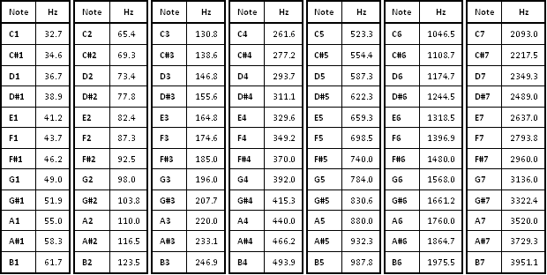
OBJECTIVES

- To understand the basics of musical notes and guitar chords.
- To determine the Fast Fourier Transform of a guitar chord.
- To plot the absolute value curve of FFT of guitar chords in MATLAB.
- To determine the frequency from the plot of absolute value of FFT.
- To determine the notes present in the given chord by the help of determined frequencies from the plot of absolute values of FFT.
METHODOLOGY

- Record the sample guitar chord.
- Gather data from the files like the sampling frequency, type of signal, gain, base and unit.
- Change the sample chord to .wav format.
- Now FFT of the chord is found out by the MATLAB program code written on the next page.
- We plot the graph of FFT and find the absolute value of frequencies.
- We find the values of hertz frequency from the absolute value of frequencies.
- Now we compute the frequencies and tally them with the table given above of the musical notes and their frequencies.
- This tells us which notes are present in the guitar chord sample.

PROGRAM CODE

- [data,fs]=audioread(“filename.wav”)
- data=data(1:1024)
- N=16;
- data=data(1:$2^{N}$);
- figure()
- clf
- plot(data)
- data1=data(1:$2^{N}$);
- data1=data1’;
- data1_fft=fft(data1,1024);
- figure,plot(abs(data1_fft));
[peaks locs]=findpeaks(abs(data1_fft));
- peaks
K1=locs(1)-1;
- k2=locs(2)-1;
- k3=locs(3)-1;

RESULTS
- E Major-
- k1=4,k2=6,k3=10
- Fs=22050
- N=22050
- w1=2π*4/1024=0.0245
- w2=2π*6/1024=0.0368
- w3=2π*10/1024=0.0613
- f1=w1*22050/2π=85.97 Hz
- f2=w2*22050/2π=129.14 Hz
- f1=w3*22050/2π=215.33 Hz
- On comparing the values of f1,f2 &f3 from table, the notes present in E Major are E,B,G#.

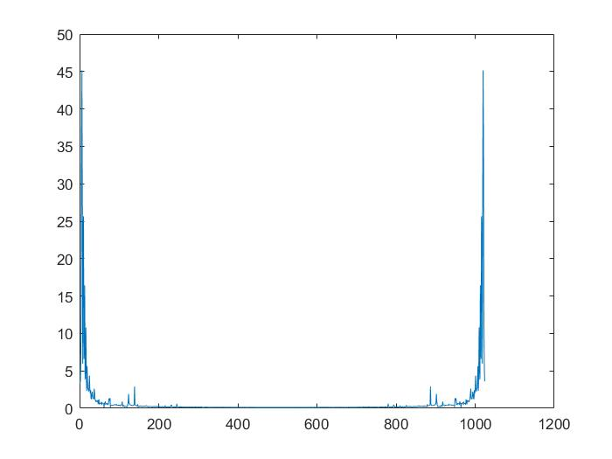
FFT of E Major.
2) C Major
Similarly notes present in C Major are C,E & G.

FFT of C Major.

3)A Major
Notes present in A Major are found to be A,C#,E. 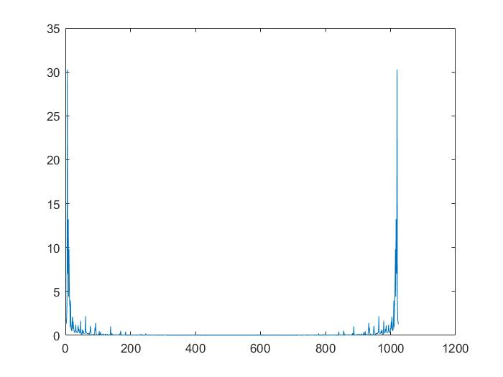
FFT of A Major.

CONCLUSION

- In this we explore how MATLAB interact with sound and learn how to detection of musical notes in guitar chords.
- The FFT algorithm is show to be good tool in context of guitar chords analysis and we successfully recognize the notes present in sampled guitar chord.
- Fast Fourier Transform is algorithm which calculates the discrete Fourier Transform of complex function easily.

BIBLIOGRAPHY

- https://en.wikipedia.org/wiki/Guitar_chord
- https://en.wikipedia.org/wiki/Fourier_transform
- https://www.mathworks.com/help/matlab/ref/fft.html#f83-998360-Y
- https://en.wikipedia.org/wiki/Musical_note
- https://www.britannica.com/science/Fourier-transform

